Peter Victoratos

CSC 411

Lab 6: Filtering Writeup

\*\*\*DISCLAIMER\*\*\* I chose a noisy image and added more noise to it so my results aren’t the prettiest.

Step 2 Images: Grayscale, Some Noise, A Little Bit Louder

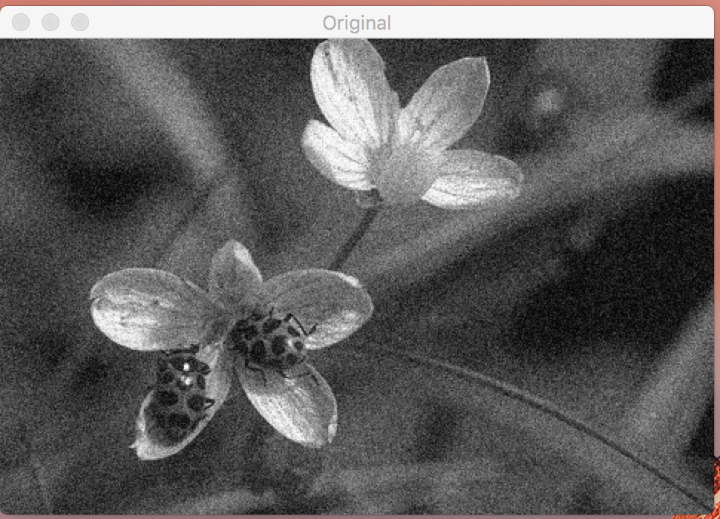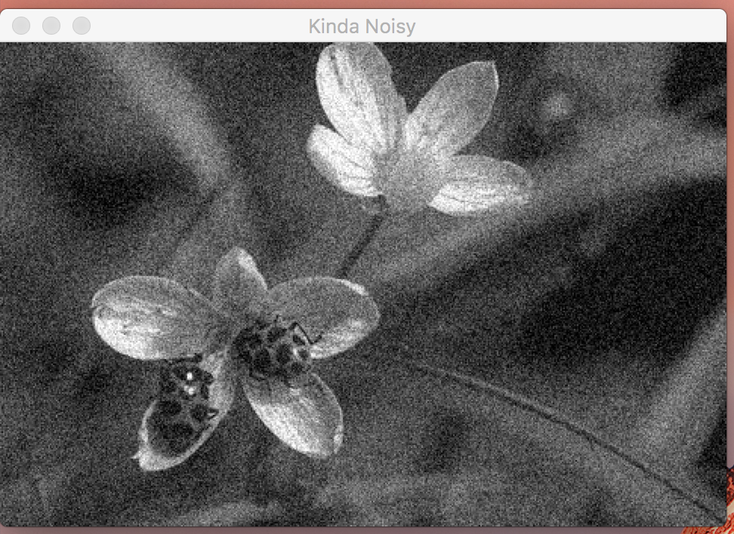

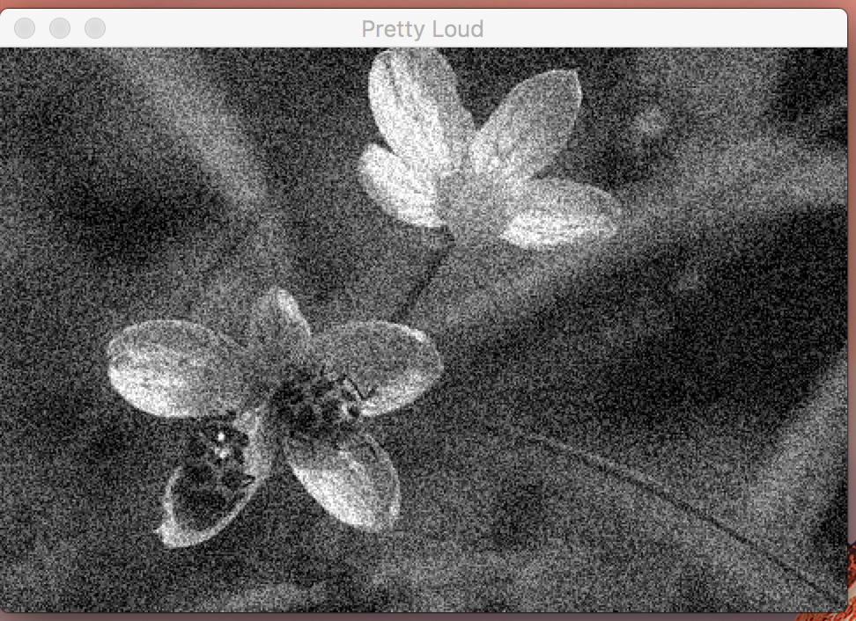

Step 3 Images: Blurring, Gaussian Blurring, Median Filtering

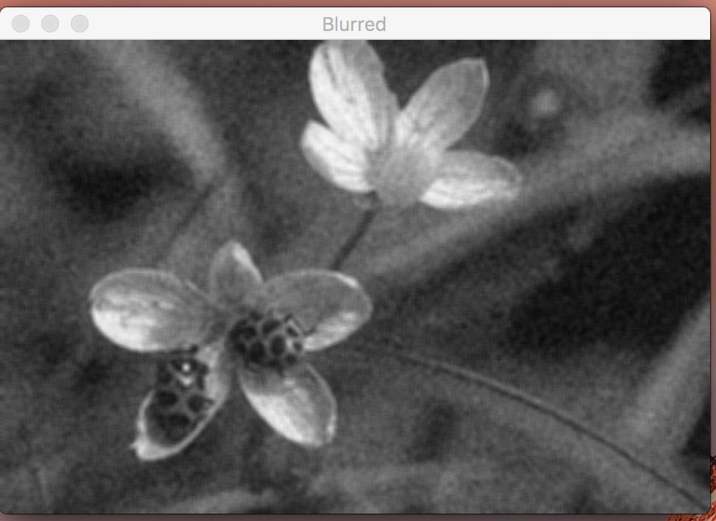

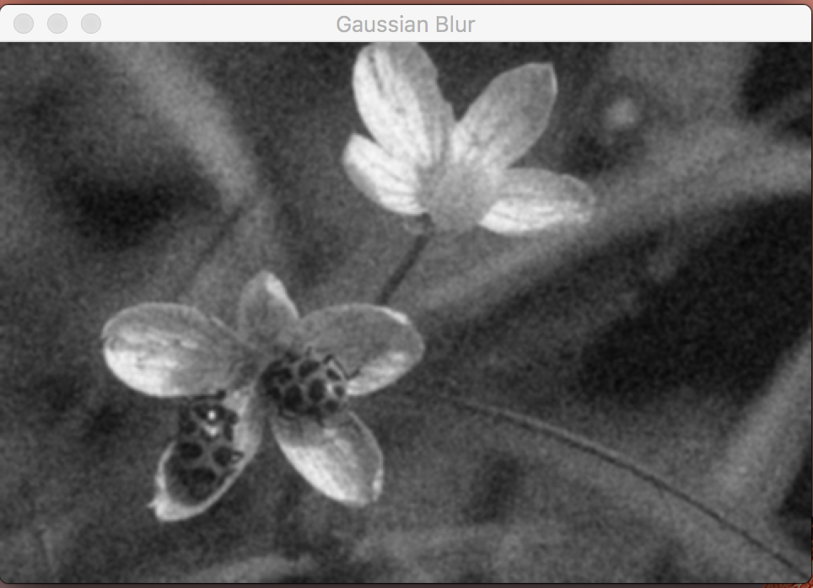

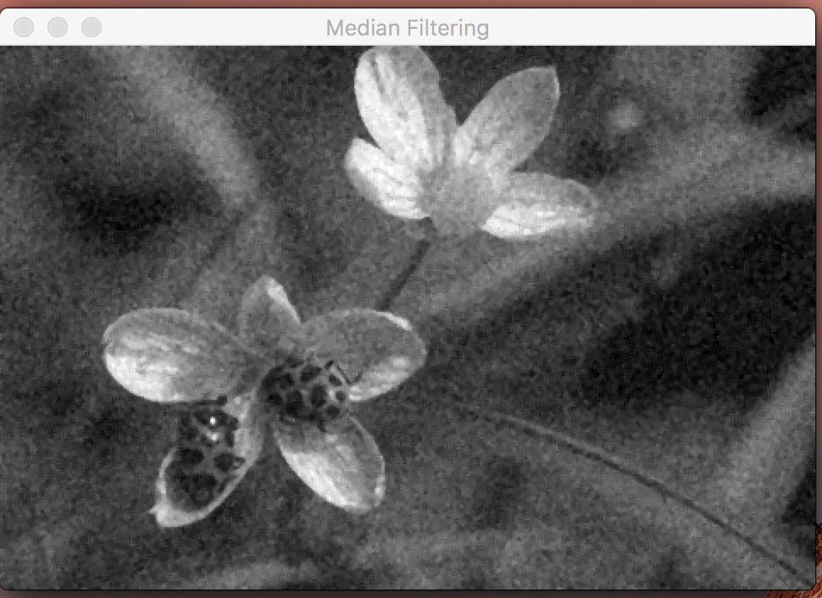

Step 4:

By taking the color values in the original image and compare it to those in the new image, you can see how much each pixel value has changed. If the averages of each neighborhood of pixels in each is relatively close, then the effectiveness is high. Vice versa for a larger gap between each comparison of pixel groups. This would be a little less effective if the image was already noisy, since the colors are already distorted.

Step 5: Manual Convolution 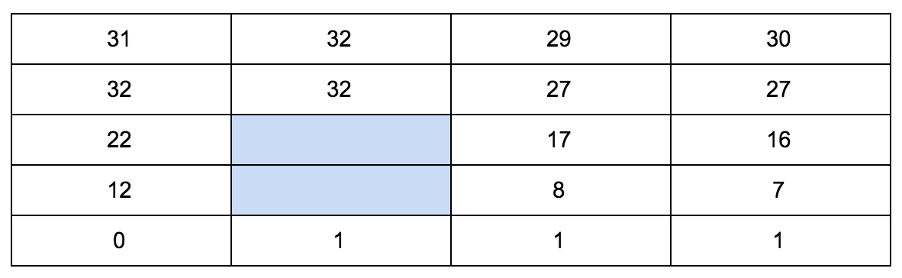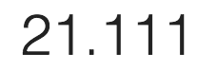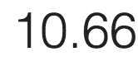

(top number for the top box, bottom for bottom)

Other Tests:

